Minimum number of bracket reversals needed to make an expression balanced
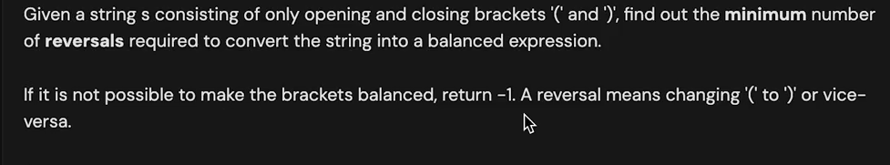
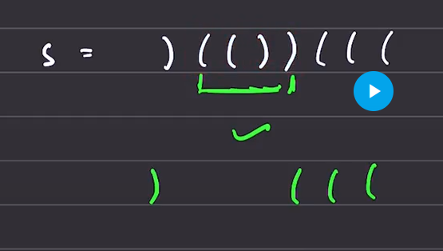
The one which are mentioned in green is already sorted or no problem in it .
Need to change the other parts of the string.
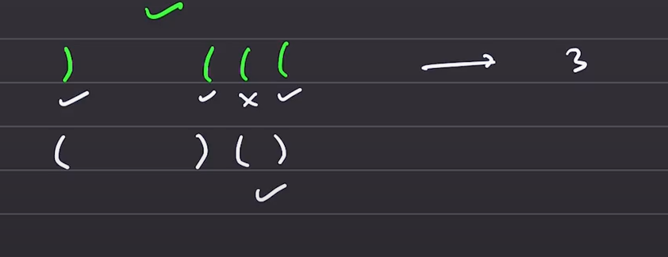
The 3 which are ticked shall be reverssed. The minimum number of reversls to be done is 3.

- Bruteforce – this is to be omplmented using the reccurence
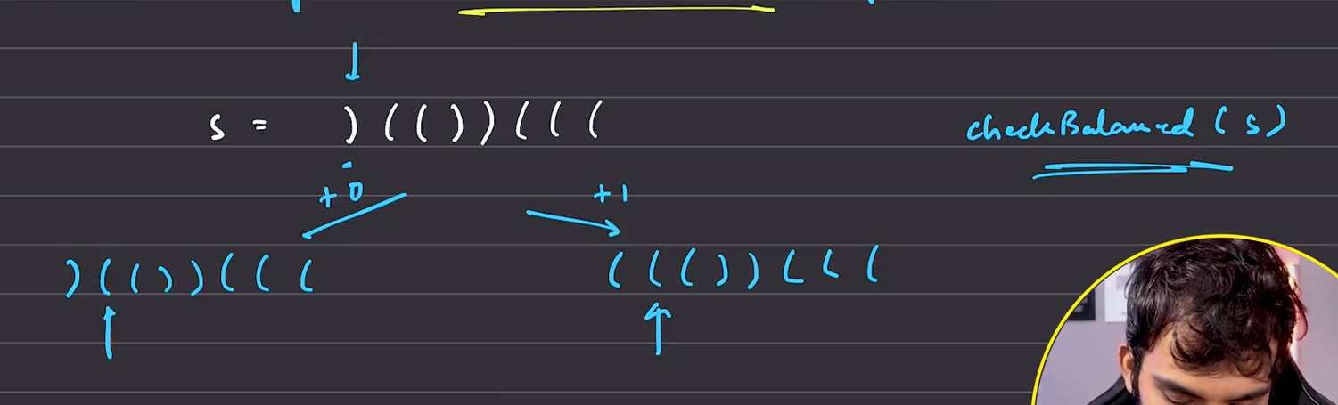
Option 1: do not change it but move to the first index element and move on to the next element , with cost 0.
2: Change the first index / reverse the first index and move on to the second index with the cost 1.
Finaly for each and every string generated, go to the string matching and minimum among all will be returned

This to be DPed, for further optimisation
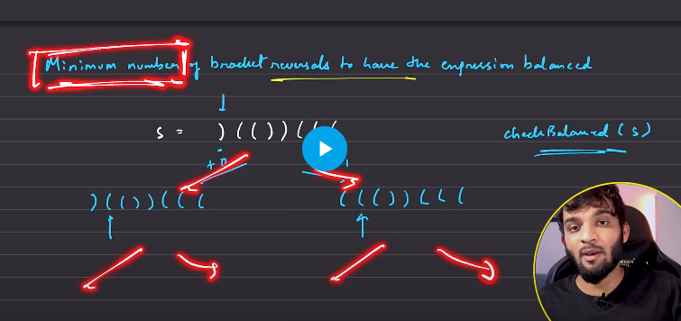
All the elements are from the
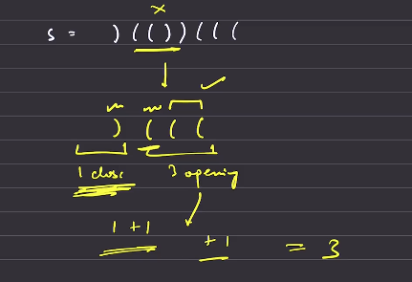
Take the 2 characters together , if both of them are in teh same direction then the number of counts required is 1.
If both of them are in opposite direction and the first one is the closing bracket then opening, then in this kind of situations we need to make the counts increment by 2.

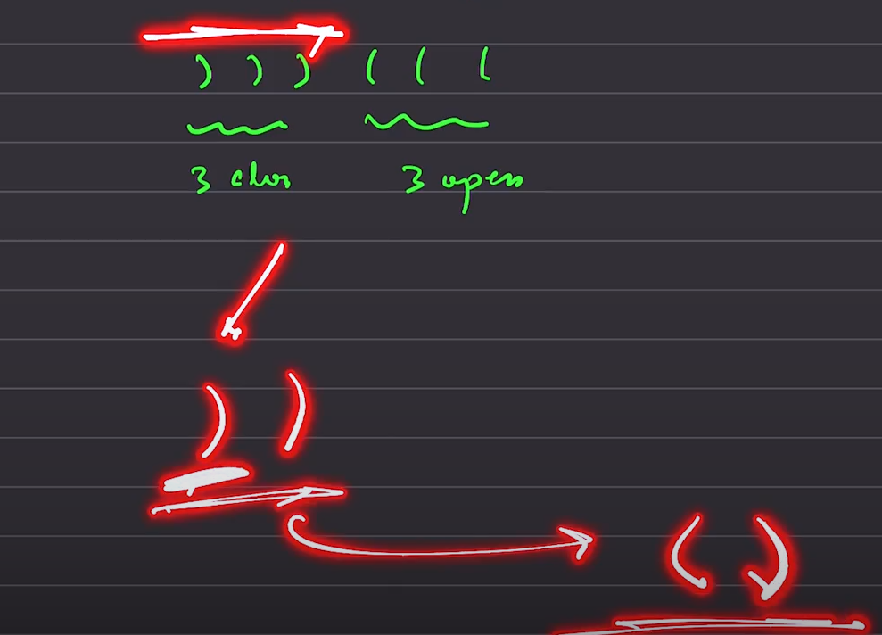
Any pair which is belong to any one of the category, then it just need one change, not 2.
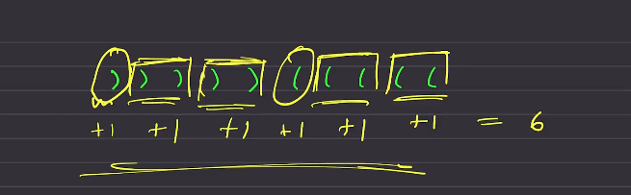
If the length of string is not even number of brackets then it is impossible to balanace.

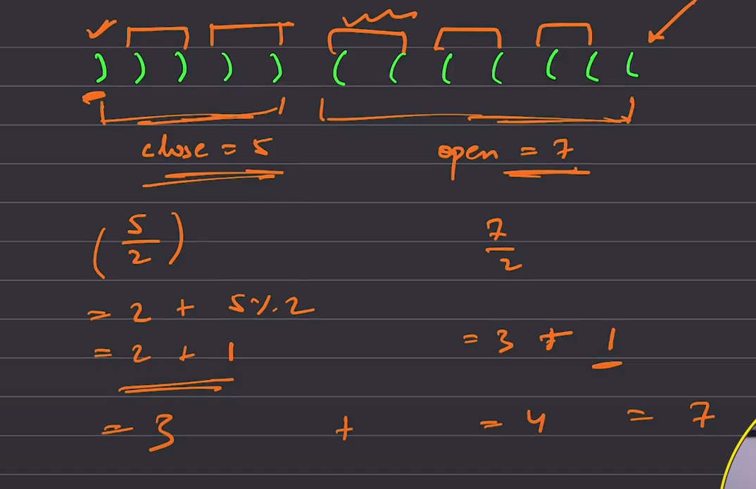
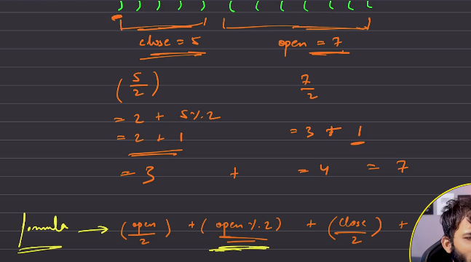
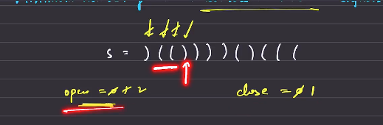
Whenever I see the closing , I’ll check whether there is an opening or not?
Hence the vaue of the open will be reduced and move on, when there is closing bracket is seen.
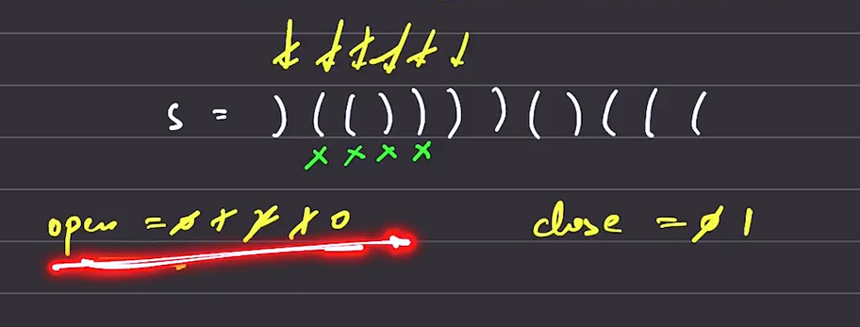

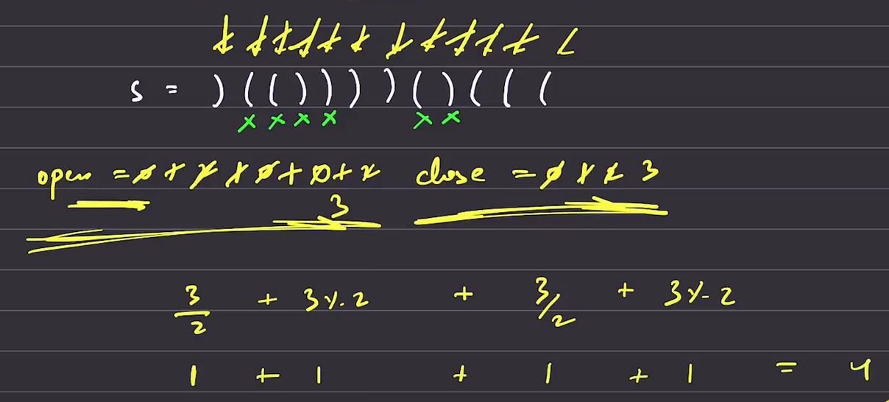
When you reached the final index, you will be utilising the formula, used above.

Count and say

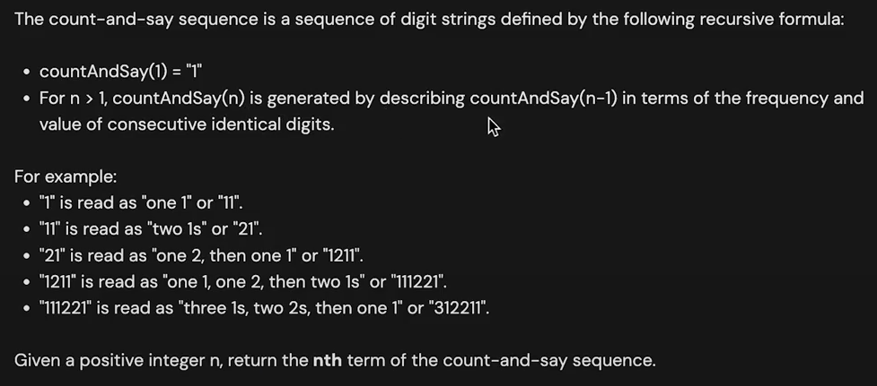
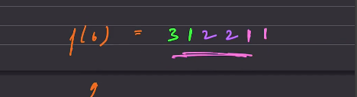
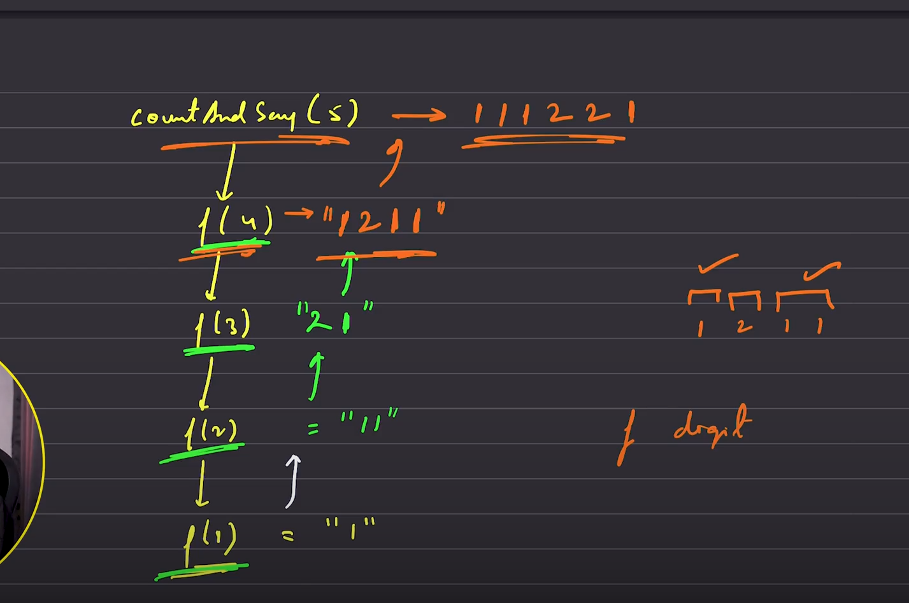

It is just telling that, whn there is f(1), it is going to return 1.
From the next time reccursive functional call says , first write the frequency and then the digit.
F(2) , it is saying, 1 has occurred once freq, and the value is 1.
This is seen the as pattern for all the entries.
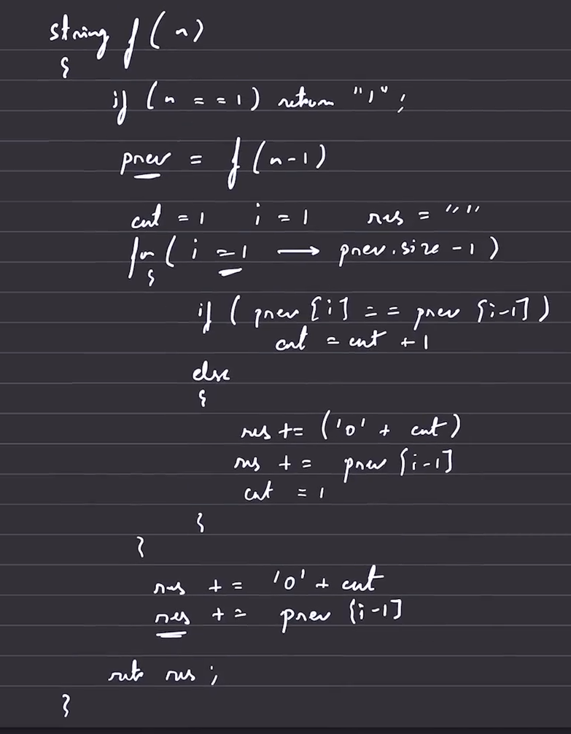

RABIN KARP ALGO
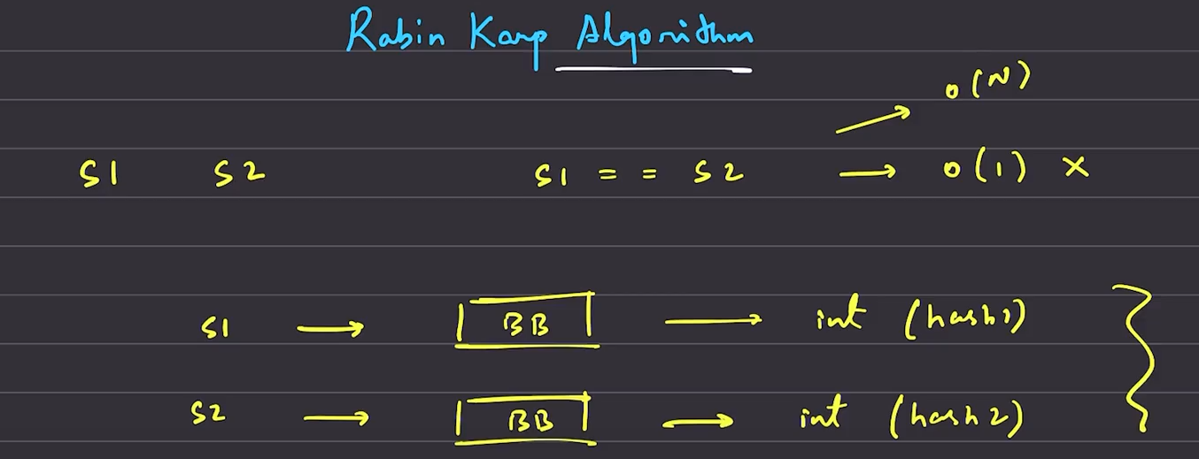
Given 2 string what is the time take to compare these 2 strings.
- O(N), if using the normal traversals and comparision
- Consider putting thse 2 strings into the BlackBox, which returns the hased value, that need to be comapared for equality.
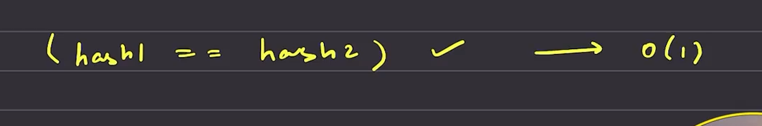
The comparision between the hashed integer values , takes O(1) time, 32 bits.

